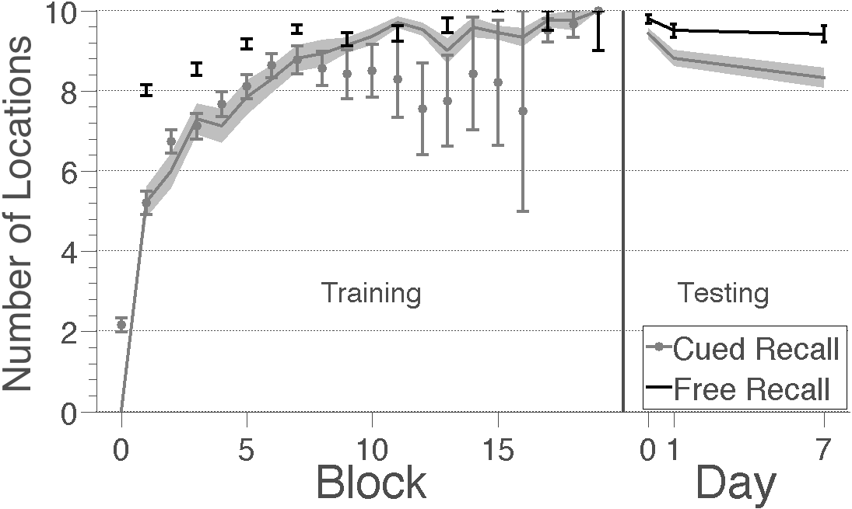
Figure 8. Estimated number of unique object locations recalled during training and testing. Grey points are the number of locations recalled in blocks of the cued recall task matched to the free recall blocks. Black points indicate the number of locations reported in the free recall task. For comparison, the shaded grey areas show the number of locations recalled in single blocks from Experiments 1 (Training) and 2 (Testing). Subjects correctly recalled more locations in the free recall task than in cued recall tasks. Error bars indicate ±1 SEM across subjects.

